- Challenge Name and Category: interencdec (Cryptography)
- Difficulty/Points: Easy.
- Description: Can you get the real meaning from this file. Download the file here.
- Flag: picoCTF{caesar_d3cr9pt3d_890d2379}
- Solution/Walkthrough: When we open the file, we will see what appears to be a base 64 encrypted string.
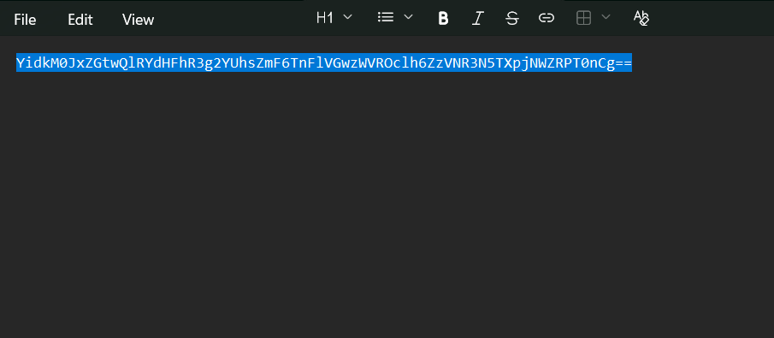
We can utilize a decryption tool such as Cyber Chef to try and decrypt this. Once we do, it appears to give us another Base64 encrypted string.
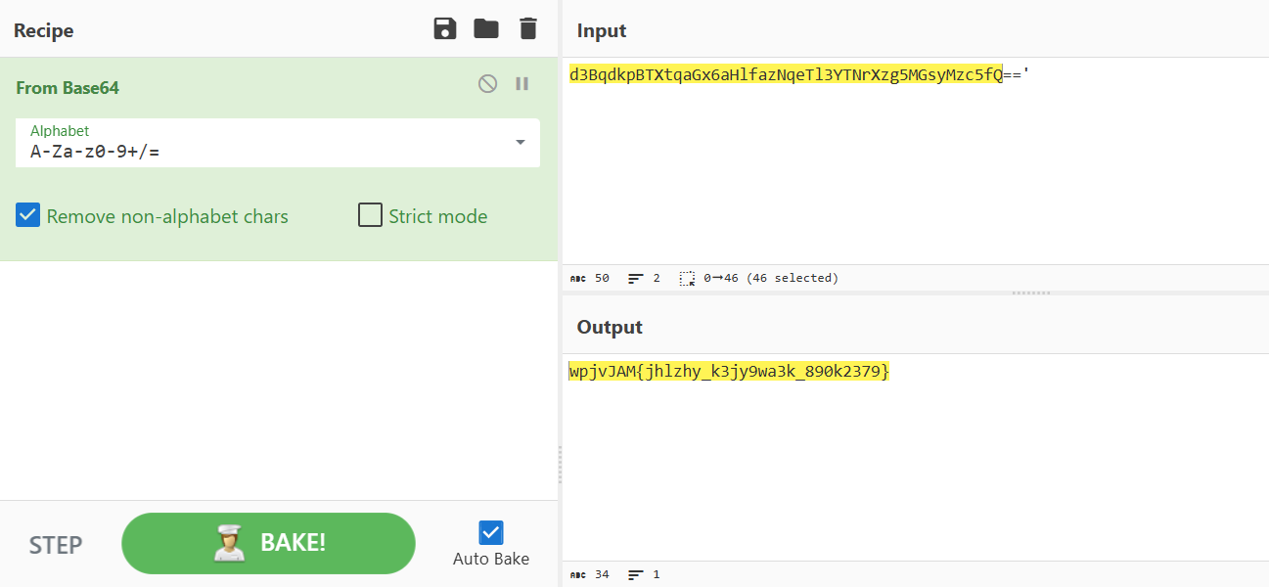
Now we see that the output has changed. It is still encoded but we can see the curly brackets which are a clue that were close to solving. The flag has been decrypted from Base64 so now it’s time to fun it through https://www.dcode.fr/caesar-cipher. This solves the ctf.
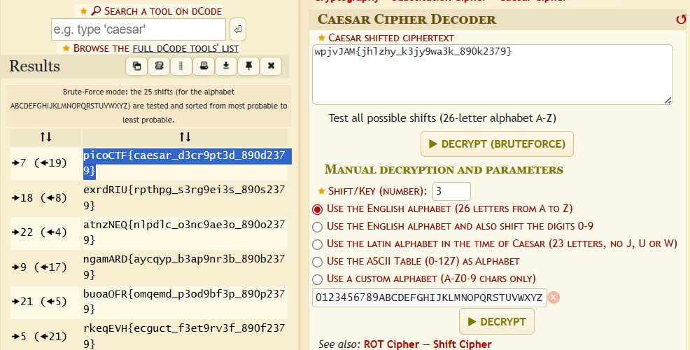
- Tools Used: https://www.dcode.fr/caesar-cipher, CyberChef
- Hypothesis Formulation: It looked like Base 64 encryption but being double encrypted threw me off the trail for a few minutes.
- What Worked vs. What Didn't: Dropping the b’ at the beginning of the second Base64 string is/was confusing to me. After dropping it the flag came through clearly.

